Armadillo Resistance Model Results

October 20, 2020

After further updates to the model by estimating the parameters from mean covariate values per step, new resistance surfaces have been produced. In this set of models, only land use-land cover (LU/LC), average daily temperature, and average daily rainfall were included. While similar, the number and types of land cover classes differed between the North and South Pantanal sites.

*North Pantanal*

As for previous versions of this model, there was not a large impact of the selected covariates on time spent per pixel when in a foraging state. For the northern site, there was little effect of temperature when in the foraging state as well, where armadillos spent the most time per pixel in “Forest” habitat (brighter patch at northernmost edge of extent). Although the pools of water are shown to have the least time spent per pixel, this is an artifact of the assumption that armadillos move in straight lines between successive observations at roughly 5 min intervals and these should be ignored. It is also notable that these armadillos did not spend much time per pixel within “Cane” habitat, as shown towards the center in different shades of purple. Armadillos at this location also spent comparable time traversing both “Fence” and “Pasture” habitat when in a foraging state.

Armadillos in the transit state spent roughly 50-80% less time per pixel when compared to the foraging state. In particular, there was not a very large impact of temperature, which differed from results in previous versions of this model. Another notable difference is that the “HQ” land use class is associated with the slowest armadillo movements (small patches of orange to yellow near the center of the extent), followed by “Forest” (the patch of magenta to purple in the top of the extent). Similar to the foraging model, time spent per pixel in “Fence” or “Pasture” land cover were comparable and armadillos spent the least time per pixel in the “Cane” class. White spots show the removal of the “Water” class, which skewed the legend and ultimately the interpretation of the results.

When observations of both behaviors were analyzed together, results were relatively similar with some noted differences. Similar to the results from both of the previous models, resistance was greatest in the small “Forest” patch and was lowest in the “Cane” land class. However, this combined model finds the “HQ” land class to result in movement almost as quickly as in “Cane”, opposite of what was found for the Transit state resistance model where resistance was greatest. “Fence” and “Pasture” land cover exhibited similar levels of intermediate resistance on the landscape, where temperature exhibited a slight positive relationship with resistance. Water estimates were removed from this model and are shown as white.

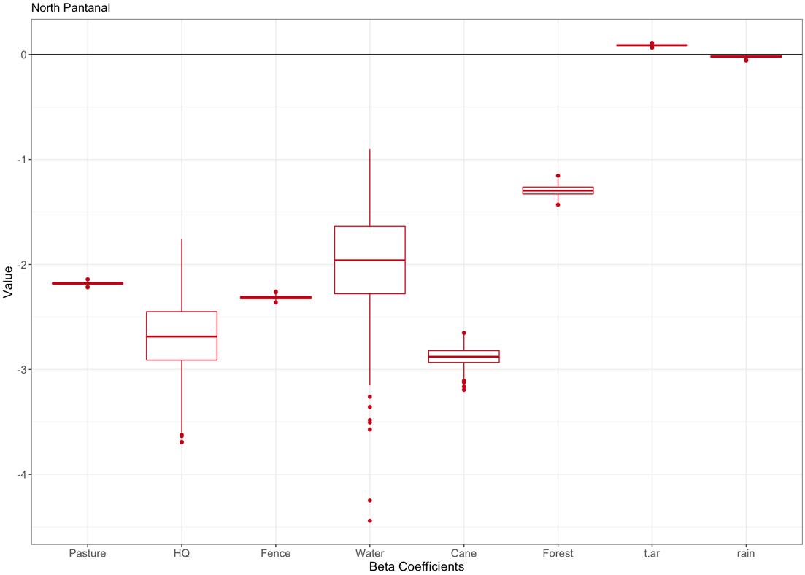

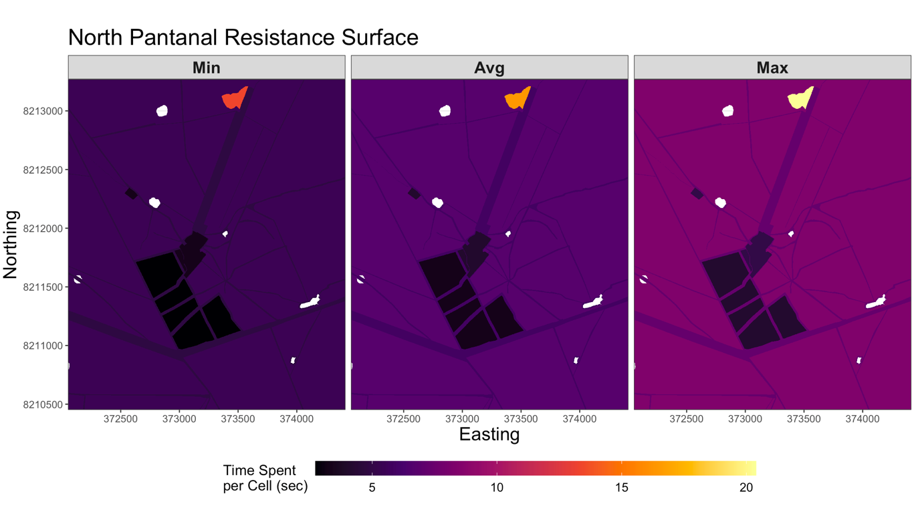

*South Pantanal*

Armadillos in the foraging state at the south Pantanal site showed a similar lack of effect by temperature and minimal differences by LU/LC. The black pixels denote “Water”, which again should be ignored as an artifact of our assumptions of armadillo movement. The most time spent per pixel was in the “Field” state (large yellow swath at bottom of extent), whereas the “Forest”, “Pasture”, and “Road” classes showed comparable time spent per pixel. These values were similar to what was calculate for the northern site.

Movement when in the transit state showed similar relationships as in the northern site, where time spent per pixel was approximately 50-80% less. Although resistance estimates are provided for this figure, they should be ignored per the previous reason mentioned. However, it appears that armadillos moved the slowest through the “Field” and “Pasture” classes. At this site armadillos in the transit state spent the least time per pixel in the “Forest” class, which is the opposite of what was found at the northern site. Time spent on roads was found to fall in the middle of these extremes.

The analysis of both behaviors combined for the southern site also resulted in similar results as in the behavior-specific models, which differed from the combined model for the northern site. The combined model also found a negative relationship between temperature and time spent per pixel, which is the opposite of what we’ve previously found. It is currently unclear why this relationship has flipped. For this site, armadillos face the least resistance on “Road” land cover, followed by “Forest” and then “Field” and “Pasture”. This is essentially the same as what was found for the behavior-specific models and the time spent per pixel matches the range found in these models as well.

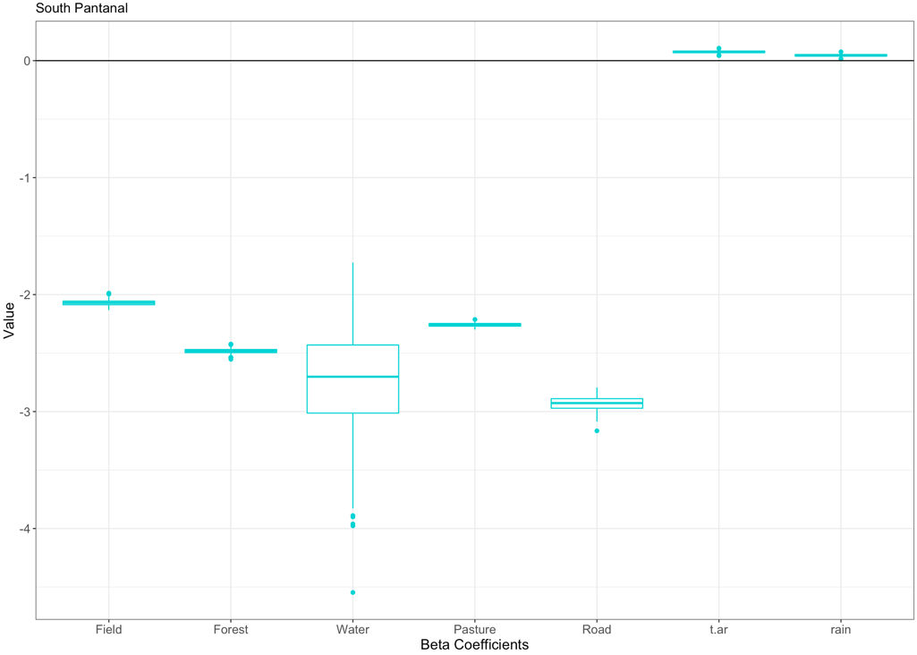

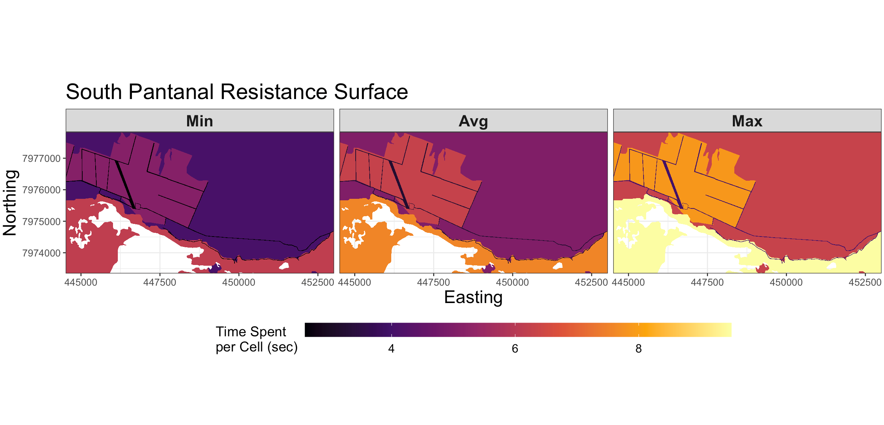

*Conclusions*

Results from this update version of the model provide some new insight, as well as confirm some previous results that were found. These models extracted data that were stored at a 1 m spatial resolution for LU/LC, whereas average daily temperature and average daily rainfall did not include a spatial component.

When in a foraging state, armadillos did not show more than a 4 s difference per pixel when comparing estimates at a given temperature across all assessed land cover classes (does not include “Water”). However, armadillos at the northern site spent the most time per pixel (12-14 s) in “Forest” land cover, but spent the least time per pixel (1.5-2.5 s) for this same class at the southern site. Apart from differences in the makeup in these forests and the availability of dietary resources, it is currently unclear why these patterns would be different by site. However, this could potentially be due to a single individual using the small patch of “Forest” for the northern site that is not traversed by any of the 9 other individuals, skewing the results of the model when not accounting for individual-based differences.

When in a transit state, armadillos moved 2-5 times faster per pixel compared to the foraging state. There was also a relatively small influence of temperature on these values, which may in part be due to the resolution of the LU/LC raster, which is now reporting time spent per pixel on the scale of seconds compared to minutes as was done previously when spatial resolution was 30 m instead of 1 m. Armadillos at the northern site moved the quickest through “Cane” land cover, but moved quickest through “Forest” land cover at the southern site.

Assuming these relationships hold true, these results provide an interesting example where armadillos respond differently to the same land cover classes at different sites. This would mean that resistance surfaces may not necessarily be generalizable across locations for the same species, at the very least when broad land cover classes are used.